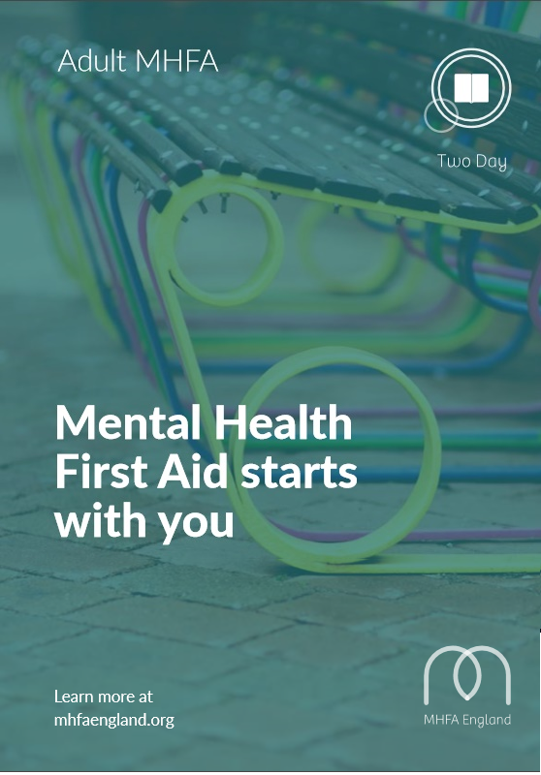

What is Mental Health First Aid?
Mental Health First Aid (MHFA) is an internationally recognised training course, designed to teach people how to spot the signs and symptoms of mental ill health and provide help on a first aid basis.
Adult MHFA courses can be attended by people aged 16 upwards and are relevant for the general population.
Everyone on an Adult MHFA course is taught a set of skills which enables them to support someone experiencing mental health issues.
Each and every MHFA course is delivered by a quality assured instructor, who has attended the seven-day instructor training programme accredited by the Royal Society for Public Health.
What will I learn on a two day MHFA course?
Our MHFA instructors deliver training in four manageable chunks, each with a focus on how to apply Mental Health
First Aid skills:
Session 1
Mental Health First Aid, mental health, and depression.
Session 2
Depression (cont.) and suicidal crisis.
Session 3
Anxiety, personality disorders, eating disorders and self-harm. Session 4
Psychosis, schizophrenia and bipolar disorder.
Everyone who attends the course will receive a copy of the MHFA manual and workbook, which are both excellent support resources. When you have completed the course you will also receive a certificate to confirm that you are a trained Mental Health First Aider.
How will becoming a Mental Health First Aider help?
The course will:
- Give a deeper understanding of the issues that impact on and relate to people’s mental health
- Teach practical skills that can be used every day, including being able to spot the signs and symptoms of mental health issues and feel confident guiding people towards appropriate support
Independent research and evaluation shows that taking part in an MHFA course:
- Raises awareness and mental health literacy
- Reduces stigma around mental ill health and feel confident guiding people towards appropriate support
- Boosts knowledge and confidence in dealing with mental health issues
- Encourages people to start a conversation with a person who may be experiencing a mental health issue
- Promotes early intervention which enables recovery
MHFA won’t teach you how to be a therapist, but you will be able to say you’re a Mental Health First Aider.
To find out more about MHFA England training and consultancy please contact:
020 7250 8062 info@mhfaengland.org www.mhfaengland.org

